# List of tables

# List of figures

# Introduction

## Purpose

## Scope

## Defintions, acronyms and abbreviations

## Reference documents

## Document structure

# Archictectural design

This section presents the architectural design of the MyTaxiService software. We first present an overview of the design and a high level description of the components. These are followed by further explanations of the components from three different perspectives (component, deployment and runtime). Finally we expose the design decisions, some of which refer to the selected architectural and styles patterns.

It is worth to mention that this document refers to a logical architecture of the system, which is platform and specific technologies independent. This means that we have not made any decisions on the language or implementation frameworks (e. g. Java EE, PHP, Ruby) that shall be used; we assume that such choices will be taken in later iterations. However, some of the expected behaviors of the implementing platforms are provided.

## Overview

## High level components and their interaction

The following diagram presents the main components of the system at a high level view. It only shows their names and the other related components and actors (either users or systems). In the *Component view* we refine this model and add deeper explanations.

**DIAGRAM HERE**

The yellow actors are the users of MyTaxiService:

* **Passenger:** makes use of the MyTaxiService to make a request for a taxi service. He can communicate with the system either through the web site or the mobile application by interacting with the appropriate subcomponents of the MTSView (this will be shown in the *Component view*).
* **TaxiDriver:** makes use of the MyTaxiService to attend requests for a taxi service. He can communicate with the system through the mobile application by interacting with the appropriate subcomponent of the MTSView.

The pink boxes represent software components that define MyTaxiService. Note that the use of the MVC architectural pattern is visible:

* **MTSView:** this component is in charge of displaying graphical components to allow both the Passenger and the TaxiDriver to interact with the system. It will communicate such interactions to the MTSController. In the *Component view* we will see that this component includes subcomponents that will support the access of the users from the different devices (computer and mobile phones).
* **MTSController:** this component is in charge of receiving the events produced by the interactions between the users and the software, and performing the corresponding invocations on the MTSModel to execute the related tasks.
* **MTSModel:** this component is in charge of receiving invocations from the MTSController and execute the appropriate operations. It implements the business logic. Some operations might involve accessing to the MTS_DB to retrieve persistent data, or to the MTSIntegration to communicate with external systems.
* **MTS_DB:** represents the Database Management System that will store the persistent data. This document does not include a Persistent view, but we expect this component to store the following information:
  + The data of the passengers, such as name, email address, password, and whether their email address has been confirmed.
  + The data of the taxi drivers, such as name, email address, username, password, taxi code, and taxi capacity.
* **MTSIntegration:** this component is in charge of communicating with the external systems of the domain (EmailServer, MapsServer, MilanoGovernment), as consequence of requests of the MTSModel.

The green actors are the external systems that MTS will interact with (these are already implemented):

* **EmailServer:** this system will be used by the MTSModel (through the MTSIntegration) to send messages to the users as described in the *External system interfaces* section of the RASD (section 2.1.2).
* **MapsServer:** this system will be used by the MTSModel (though the MTSIntegration) to perform location analysis tasks as described in the *External system interfaces* section of the RASD (section 2.1.2).
* **MilanoGovernment:** this system will be used by the MTSModel (though the MTSIntegration) to perform data validation tasks as described in the *External system interfaces* section of the RASD (section 2.1.2).

## Component view

This section provides further details on the components defined in the previous section. We have identified subcomponents aiming to the *Deployment view* and the two different users, which will also be more detailed as they are explained in this subsection (by means of class diagrams).

The data types used to describe some classes should be understood as language independent; using names or notations which are recurrent in some languages does not mean that we have decided to use them. This is also valid for collections of objects; these do not necessarily have to be Lists. More appropriate data structures can be derived in more detailed design documents.

**DIAGRAM HERE**

In the following subsections we expose the descriptions of the components in the diagram above. We only give their definition since the interfaces are defined later in the document. The components are grouped by the high level component that they refine.

### MTSView

The MTSView component has three subcomponents: MTSPassengerWebView, MTSPassengerMobileView and MTSTaxiDriverMobileView.

#### MTSPassengerWebView

This subcomponent will be used by the Passenger whenever he accesses the web site of MyTaxiService. It will communicate to MTSPassengerWebController, the corresponding subcomponent of MTSController.

The class diagram of the classes encapsulated by this subcomponent. Is analogous to the one in the MTSPassengerMobileView, so it is not presented here.

The Web Browser used by the Passenger to access the web site of MyTaxiService, so it will be the one that will communicate with the MTSPassengerWebView to get the required web pages that will be shown to the user.

#### MTSPassengerMobileView

This subcomponent will be used by the Passenger whenever he uses the MyTaxiService mobile application. It will communicate to MTSPassengerMobileController, the corresponding subcomponent of MTSController.

The following is the diagram of the classes encapsulated by this subcomponent.

**DIAGRAM HERE**

**CLASSES DESCRIPTION HERE**

#### MTSTaxiDriverMobileView

This subcomponent will be used by the TaxiDriver whenever he uses the MyTaxiService mobile application. It will communicate to MTSTaxiDriverMobileController, the corresponding subcomponent of MTSController.

The following is the diagram of the classes encapsulated by this subcomponent.

**DIAGRAM HERE**

**CLASSES DESCRIPTION HERE**

### MTSController

The MTSController component has three subcomponents: MTSPassengerWebController, MTSPassengerMobileController and MTSTaxiDriverMobileController.

#### MTSPassengerWebController

This subcomponent will be used by the Passenger whenever he accesses the web site of MyTaxiService. It will communicate to MTSPassengerWebController, the corresponding subcomponent of MTSController.

The diagram of the classes encapsulated by this subcomponent is analogous to the one in the MTSPassengerMobileController, so it is not presented here.

#### MTSPassengerMobileController

This subcomponent will be used by the Passenger whenever he uses the MyTaxiService mobile application. It will communicate to MTSPassengerMobileController, the corresponding subcomponent of MTSController.

The following is the diagram of the classes encapsulated by this subcomponent.

**DIAGRAM HERE**

**CLASSES DESCRIPTION HERE**

#### MTSTaxiDriverMobileController

This subcomponent will be used by the TaxiDriver whenever he uses the MyTaxiService mobile application. It will communicate to MTSTaxiDriverMobileController, the corresponding subcomponent of MTSController.

The following is the diagram of the classes encapsulated by this subcomponent.

**DIAGRAM HERE**

**CLASSES DESCRIPTION HERE**

### MTSModel

This component has only one subcomponent with both the same name and function as its parent.

The following is the diagram of the classes encapsulated by this subcomponent.

**DIAGRAM HERE**

* **IPassengerModel:** this interface represents the operations that the MTSModel provides to the Passenger:
  + Cancel a request, given the email address of the passenger (which uniquely identifies the request). If necessary, the involved TaxiDriver and Passengers are notified. The corresponding requests are deleted.
  + Confirm the email address, given the email address of the passenger. By doing this, the Passenger will be able to successfully login to the system.
  + Create an account, given the information of the Passenger. Returns the created Passenger object if the creation is successful.
  + Edit an account, given the new information of the Passenger. Returns the edited Passenger object if the edition is successful.
  + Get a map, given a GPSLocation. Returns the Map that the MapsServer provides for that location.
  + Get the status of a request, given the email address of the passenger. Returns the RequestForService object, associated to its corresponding AcceptedRequest if any.
  + Login to the system, given the email address and the password of the passenger. Returns the existing Passenger object if the logins is successful.
  + Receive a request for service, given the corresponding information. Returns true it is successfully received and false otherwise.
* **PassengerModel:** is a concrete implementation of the IPassengerModel interface. Thus, it will implement the inherited methods.
* **ItaxiDriverModel:** this interface represents the operations that the MTSModel provides to the TaxiDriver
  + Add an incoming request: given the code of a taxi and an incoming request, it add this incoming request to the taxi driver. Then the taxi driver is notified.
  + Answer a request: Assume a taxi driver as received an incoming request. Given the code of this taxi driver and a boolean that represents the answer of the request it will start the process of answering that is depends on the value of the answer.
  + Cancel a request: Assume a taxi driver as already accepted a request. Given the code of this taxi driver, the related requests (incoming request, accepted requests, requests for service) will be delete and the taxi driver and the passengers notified
  + Create an account: Given the code of a taxi driver, it will ask the Milano government and return an instance of taxi driver if the code is correct.
  + Edit an account: Given the code of a taxi driver and some information such as a new password, a new capacity, a new email address and in the case the provided email address is valid, it will modify the information in the data base and return the updated instance of the taxi driver
  + Get a map: Given a GPS position, return the map the map server provide for that location
  + Log in to the system: Given a taxi driver code and a password, return the created instance of taxi driver if the login information are validation
  + Remove an incoming request: given the code of a taxi, it removes this incoming request from the taxi driver.
  + Set the availability status: Given a taxi driver code and a boolean representing his new availability, it will modify this attribute and update the taxi driver position in the zone queues.
  + Update the GPS position : Given a taxi driver code and a GPSPosition provided by the hardware, it will modify this attribute and update the taxi driver position in the zone queues
* **TaxiDriverModel:** is a concrete implementation of the ItaxiDriverModel interface. Thus, it will implement the inherited methods.
* **RequestManager:** this class is supposed to receive valid RequestForService and process them. It keeps the collection only of the RequestForService that have been sent to a taxi driver (either the response has or not been received). In order to do so, it offers the following operations:
  + Receive and accepting response from a TaxiDriver, given the IncomingRequest that was sent and accepted to him, and which is associated to the corresponding RequestForService. The involved Passengers are notified.
  + Calculate the fee of a request, given the IncomingRequest that has the information of the ride in its RequesForService. The specific procedure of this calculation is shown in the *Algorithm design* section.
  + Cancel a request when done by a Passenger, given his email address. If necessary, the involved TaxiDriver and Passengers are notified. The corresponding requests are deleted.
  + Receive a declining response from a TaxiDriver, given the declined IncomingRequest.
  + Delete a request: given an incoming request, it will delete it and all the request and accepted request related as well.
  + Delete a request, given the email address of the passenger who owns it.
  + Find a taxi driver, given the IncomingRequest. Once found, the IncomingRequest will be sent.
  + Find a taxi driver, given the RequestForService. It will also generate the IncomingRequest and send it to the driver.
  + Find a taxi driver, given the SharingRequest. It will also generate the IncomingRequest and send it to the driver.
  + Generate an IncomingRequest, given the RequestForService of the ride. Returns the generated IncomingRequest, ready to be sent to a TaxiDriver.
  + Generate an IncomingRequest, given the SharingRequest of the ride. Returns the generated IncomingRequest, ready to be sent to a TaxiDriver.
  + Get the information of a request, given the email address of the related Passenger. Returns the corresponding RequestForService.
  + Process a request, given the RequestForService information. This means to generate the appropriate IncomingRequest and to try to find a TaxiDriver to whom send the request.
  + Process a request, given the SharingRequest information. This will dispatch the request to the pertinent class (SharingEngine or ReservationManager) or will process it if it is ready to be processed.
* **ReservationManager:** this class is supposed to receive the reservation requests for later processing. In order to do so, it provides the following operations:
  + Cancel a request, given the email address of the Passenger. This means to delete the request (since it has not been processed yet).
  + Check if a request is the reservation list, given the email address of the Passenger. Returns true if it is in there, and false otherwise.
  + Receive a request to book, given the RequestForService. This means to schedule the processing and store the request in the MTS_DB.
  + Retrieve a request, given the email address of the Passenger. It returns the corresponding RequestForService.
  + Schedule a request for later processing, given the RequestForService.
* **SharingEngine:** this class is supposed to receive the sharing requests and try to find compatible ones. This class keeps a list of SharingRequests that have not been completed yet. In order to do so, it provides the following operations:
  + Cancel a request, given the email address of the Passenger. This will delete the request from the associated SharingRequest.
  + Delete a request, given the email address of the Passenger.
  + Get a request, given the email address of the Passenger. This returns the instance of the RequestForService.
  + Get the list of the SharingRequest whose origin is the given Zone.
  + Receive a request, given the RequestForService. This will try to associate the request to a compatible of SharingRequest, or create a new one for it if none is found.
* **QueueManager:** this class is supposed to manage the zone queues of the TaxiDrivers. It keeps a collection of the zones and of the queues of the drivers’ codes for each one of them. In order to do so, it provides the following operations:
  + Add a taxi driver to a queue, given the GPSPosition and the code of the TaxiDriver. This means to look for the appropriate zone for the driver and add it to the associated queue.
  + Get an available driver for a request, given the IncomingRequest. This is done based on the origin zone and the amount of people.
  + Get reachable zones from a path, given the path (as a collection of GPSPositions) and the radius. This returns the zones that can be reached from the path at a distance equals to the radius. This is used by the SharingEngine, as it will be described in the *Algorithm design.* It returns a collection of Zones.
  + Get a zone, given the GPSPosition. This returns the Zone for that Position.
  + Remove a driver from a queue, given the code of the TaxiDriver.
  + Send a driver to the top of the queue, given his code and GPSPosition.
  + Update a driver’s position, given his code and GPSPosition.
* **DataManager:** this class is supposed to decouple the access to the MTS_DB from the rest of the components. This class will provide operations on the data that will be translated into queries and sent to the MTS_DB. In order to do so, it provides the following operations
  + Confirm the email address of the passenger, given the email address. It will change the corresponding attributes in the MTS_DB.
  + Add a passenger to the system, given the Passenger. It returns the created instance of the Passenger
  + Delete a request, given the email address of the Passenger.
  + Edit a passenger in the system, given the Passenger. It returns the edited instance of the Passenger.
  + Get the information of a passenger, given his email address. It returns the instance of the Passenger.
  + Check if the login information of a passenger is correct, given the email address and password.
  + Retrieve the information of a request, given the email address of the Passenger. It returns the corresponding RequestForService.
  + Store the information of a request, given the RequestForService.
  + Create an account for the taxi drive. This method stores the information concerning the instance of a taxi driver provided as argument (it is supposed to be send by the Milano government) then return this instance.
  + Edit the account of the taxi driver. This method changes the information given in argument concerning the taxi driver related to the code given: the capacity, the email address if it is valid and the password. Then it returns the updated instance of this TaxiDriver.
  + Login a taxi driver. Given a taxi code and a password, if they are valid, it returns the instance of the related TaxiDriver.
* **Passenger:** it holds the information of a passenger: name, email address, password, and whether its email has been confirmed or not.
* **RequestForService:** it holds the information of a request sent by a passenger: amount of people, destination and origin (in the form of GPSPosition, address and zone), estimated path from the origin to the destination, pick-up time, start of processing time (in order to apply the timeouts), whether it is a reservation or not, and whether it is a sharing or not. Note that not all of this data is provided by the Passenger. The origin and destination zones are obtained through the QueueManager, the origin and destination positions and the estimated path through the MapsServer (when not indicated by the passenger), the processing time is written by the RequestManager.
* **IncomingRequest:** holds the information of an incoming request that can be sent to a taxi driver. It includes the fee but has also access to the origin and destination through the RequestForService.
* **AcceptedRequest:** holds the information of an accepted request for a passenger: the estimated arrival time (calculated with the MapsServer), the fee of that passenger, and the relevant information of the TaxiDriver (name, taxi code, position).
* **SharingRequest:** holds the information of a sharing request: time of the creation of the instance (for applying the timeouts), origin zone, and the collection of reachable zones (calculated by the QueueManager). It puts together a set of compatible RequestForService.
* **TaxiDriver:** It is the class that represents the taxi drivers, it owns different attribute: available, capacity, code, email, name, password, username, GPS position, incoming request. Instances of this class are created through a method belonging to TaxiDriverModel if it is called by the taxi driver interface. It is possible to edit some attributes, add and remove an incoming request and update the GPS position threw the interface.
* **GPSPosition:** It represents the information of a spatial position with two attributes: the latitude and the longitude.
* **Zone:** It represents an area of the city. It is defined by a set of three or more GPS positions that are the angles of a polygon. Each zone is identified by its ID.
* **Path:** It is a set of GPS position that define a path through the city roads.
* **Itinerary**: It owns a path, a distance as a float and a duration as a float as well.

### MTS_DB

This component has only one subcomponent with both the same name and function as its parent.

### MTSIntegration

This component has only one subcomponent with both the same name and function as its parent.

The following is the diagram of the classes encapsulated by this subcomponent.

**DIAGRAM HERE**

* **IEmailServer:** this interface represents a proxy for the EmailServer external system. The communication to that server is going to be managed here. The provided operations by this class are translated into messages that are sent to the EmailServer. In order to do so, I provides the following operations:
  + Send a confirmation email, given the email address of the passenger. This includes the appropriate creation of the message.
  + Check whether the email address is a valid one.
* **EmailServer:** is a concrete implementation of the IEmailServer interface. Thus, it will implement the inherited methods.
* **IMapsServer:** this interface represents a proxy for the MapsServer external system. The communication to that server is going to be managed here. The provided operations by this class are translated into messages that are sent to the MapsServer. In order to do so, I provides the following operations:
  + Convert an address into a GPSPosition, given the address.
  + Get the Map related to one location, given the GPSPosition of the location.
  + Get a shortest possible path between two locations, given the GPSPositions. It returns a list of GPSPosition that represent the Map.
  + Convert a position into an address, given the GPSPosition.
  + Check whether a position is valid, given the GPSPosition.
* **MapsServer:** is a concrete implementation of the IMapsServer interface. Thus, it will implement the inherited methods.
* **IMilanoGovernment:** this interface represents a proxy for the MilanoGovernment external system. The communication to that server is going to be managed here. The provided operations by this class are translated into messages that are sent to the MilanoGovernment. In order to do so, I provides the following operations:
  + Get the information of a taxi driver, given the taxi code. Returns the instance of the TaxiDriver.
* **MilanoGovernment:** is a concrete implementation of the IMilanoGovernment interface. Thus, it will implement the inherited methods.

### MTSNotifier

This component is in charge of sending the notifications to the passenger and the taxi driver when they are logged in the mobile application.

The following is the diagram of the classes encapsulated by this subcomponent.

* **INotifier:** this interface represents the operations that the class is going to provide to the MTSModel:
  + Send an accepted request, given the AcceptedRequest. This will notify the passenger about the acceptance of a request.
  + Send a cancellation notification to a taxi driver, given the TaxiDriver. This will notify the driver about the respective cancellation.
  + Send a cancellation notification to a passenger, given the Passeger. This will notify the passenger about the respective cancellation.
  + Send an incoming request to a taxi driver, given the IncomingRequest. This will notify the driver about the new request.
* **Notifier:** is a concrete implementation of the INotifier interface. Thus, it will implement the inherited methods

As we will explain later, this component corresponds to the Publisher in a Publish-subscribe architecture. The Subscribers are the Listener components (PassengerNotificationListener and TaxiDriverNotificationListener), which will receive the notifications and will make the Controller to update the View.

## Deployment view

In this subsection we present the physical distribution of the components in the *Component view*. Given that this document gives a logical architecture of the system, we do not specify communication protocols or deployment units; we will only refer to some attributes that the corresponding implementations in later iterations should satisfy in order to get the expected system behavior.

The components have already been described so we only give explanations on the nodes:

* **PC:** it represents the computer from where the Passenger will access the web site of the MyTaxiService system; that is why it contains the WebBrowser component.

It will connect to the WebServer to get the web pages that will be displayed to the passenger, and to communicate the passenger interactions on those pages.

* **WebServer:** is the machine that will contain the web view, so here we deploy the MTSPassengerWebView and MTSPassengerWebController components. These components are deployed inside a WebContainer, which is a server application capable of receiving requests for pages and the interactions of the users on those pages, and sending the response to the clients. Thus it is capable of holding sessions with the clients. Non concurrency is needed here since the instances are unique for each session

It will connect the AppliationServer to communicate the requests for actions on the logic (which are the result of the MTSController interpreting the interaction on the pages). This implies that the WebContainer should also be capable of sending remote invocations on the objects in the ApplicationServer and receive the responses.

* **ApplicationServer:** is the machine that will contain the business logic, so here we deploy the MTSModel, MTSIntegration and MTSNotifier components. They will be deployed inside an ApplicationContainer, which is a server application capable of receiving requests for actions on the model. This it is capable managing the concurrent access to the components. No sessions are needed to be held since the instances are the same for very client (e. g. all the users connect to the same RequestManager). This is also capable of receiving and handling remote invocations on the objects in the components.

This machine will also have a DBMS to deploy the MTS_DB. This is a server application capable of receiving requests to the MTS_DB. This is capable of managing the database under the usual conditions (concurrency, reliability, etc.).

The machine will connect to the external nodes EmailServer, MapsServer, and MilanoGovernment. It will also connect to the mobile phones of the passenger and the taxi driver to send the notifications.

* **PassengerMobile:** is the mobile phone that the passenger will use launch the application of MyTaxiService, so here we deploy the MTSPassengerMobileView, MTSPassengerMobileController and the PassengerNotificationsListener. They will be deployed inside a MobileApplication, a software that runs in a mobile phone that displays the graphic components to the passenger and handles the interactions on them. It is also capable of receiving the notifications from the ApplicationServer.

It will connect the AppliationServer to communicate the requests for actions on the logic. This implies that the MobileApplication should also be capable of sending remote invocations on the objects in the ApplicationServer and receive the responses.

* **TaxiDriverMobile:** is the mobile phone that the passenger will use launch the application of MyTaxiService, so here we deploy the MTSPassengerMobileView, MTSPassengerMobileController and the PassengerNotificationsListener. They will be deployed inside a MobileApplication, a software that runs in a mobile phone that displays the graphic components to the passenger and handles the interactions on them. It is also capable of receiving the notifications from the ApplicationServer.

It will connect the ApplicationServer to communicate the requests for actions on the logic. This implies that the MobileApplication should also be capable of sending remote invocations on the objects in the ApplicationServer and receive the responses.

* **EmailServer:** is the machine in which the EmailServer is deployed.
* **MapsServer:** is the machine in which the MapsServer is deployed.
* **MilanoGovernment:** is the machine in which the MilanoGovernment is deployed.

## Runtime view

Along this subsection it is exposed a dynamic view of the system by means of sequence diagrams. These are supposed to show the interactions between the components (and their internal items) that are performed to respond to the user actions on the software.

When the classes of the Notifier components are used, we omit the part on how the message gets to the corresponding Listener for the sake of simplicity. This process only includes the invocation of the Listener from the Notifier and the subsequent handling of the notifications by the Controller, which will be an update of the View.

### A passenger cancels a request

This diagram shows how the system reacts to the cancellation of a request by a passenger.

### A passenger confirms his email address

This diagram shows how the system reacts when a passenger accesses the link that confirms his email address.

### A passenger creates an account

This diagram shows how the system reacts when a passenger creates an account.

### A passenger edits an account

This diagram shows how the system reacts when a passenger edits his account.

### A passenger wants to get the status of his request

This diagram shows how the system reacts when a passenger wants to see the status of his request.

### A passenger logs in

The diagram shows how the system reacts when a passenger wants to log into the system.

### A passenger sends a request

This diagram shows how the system reacts when a passenger sends a request. This is one of the most complex processes of the software, so we have separated it in various diagrams.

The first one only shows what happens until the RequestManager begins to process the request in an asynchronous way, which allows the system to send the confirmation message to the passenger and process the request later.

The processing is explained with detail in the *Algorithm view* section.

## Component interfaces

We will present in this part of the document the interfaces relevant for each component identified in the *Component view*. To do so, we describe the required and provided interfaces, and the corresponding operations that can be executed on them. Note that the *Deployment view* induces remote and local interfaces on some of the components, but we assume that both of them will provide the same operations.

**WebBrowser** It needs to communicate with the MTSPassengerWebView that will provide it all the displaying information. The WebBrowser interface is on the one hand responsible of the transmission of the displaying command from the MTSPassengerWebView to the WebBroswer and on the second hand is responsible of the way back transmission of the input event received by the web browser.

**MTSPassengerWebView** It provides information to the WebBrowser and needs to communicate with the MTSWebController as well. The PassengerWebController interface is in charge to give displaying command from the controller to the MTSPassengerWebView and to transmit input event in the opposite direction.

**MTSPassengerWebController** It provides displaying orders to the MTSPassengerWebView that are based on the information received from the MTSModel. It also receives notifications about input event from MTSPassengerView then sends the appropriate requests to the MTSModel. So it needs a PassengerModel interface that allows it to communicate with the MTSModel. This interface is used to call the PassengerModel methods and to receive results of those calls.

**MTSPassengerMobileView** It has the same behavior than the MTSPassengerWebView unless that it doesn't need a WebBrowser intermediary but works on its own inner the mobile. The interface between it and the MTSPassengerMobileController has the same purpose than the one batween the WebView and the WebController.

**MTSPassengerMobileController** It has the same behavior than the MTSPassengerWebController. It communicates with the MTSPassengerMobileView for sending displaying commands and receiving input event notifications. It also communicates with the MTSModel through a PassengerModel interface to call the PassengerModel methods and receive results of those calls.

**MTSDriverMobileView** It has the same behavior than the MTSPassengerMobileView unless that it communicates with the MTSDriverMobile Controller.

**MTSDriverMobileController** It has the same behavior than the MTSPassengerMobileController unless it communicates with the MTSModel through a TaxiDriverModel interface.

**MTSModel** Its methods are called by the controllers and it sends back to them the results. It has an interface with the MTSDataBase to send some write and read requests and receive the results. It has also an interface with the MTSIntegration component to call some methods that belong to external components and receive the results of those.

**MTSDataBase** It communicates only with the MTSModel to receive from it some read or write requests and send back some results.

**MTSIntegration** This component share an interface with the MTSModel that sends some external methods calls that will be transferred trough others interfaces either to the MapServer, the EmailServer or the MilanoGovernment component. These one will send back the results of those methods that will be transferred to the MTSModel

**MapServer, EmailServer, MilanoGovernment** It exists an interface between each of them and the MTSIntegration. It allows the MTSIntegration to call some external methods and get the result of those.

## Selected architectural styles and patterns

The previously presented architecture was guided by some architectural styles and patterns. Now we present them and we explain how they have been adopted within this specific context.

* Model-View-Controller:

It was used to logically decouple the graphic logic and the business logic. This allows to perform parallel design and implementation of those components. It also enables reuse of the business logic component from any graphic component (e. g. the web view and the mobile view use the same model).

The implementing components are:

* + Model: MTSModel.
  + View: MTSPassengerWebView, MTSPassengerMobileView and MTSTaxiDriverView.
  + Controller: MTSPassengerWebController, MTSPassengerMobileController and MTSTaxiDriverController.
* Multi-tier:

It was used to physically decouple the graphic logic and the business logic. This allows to perform independent maintenance of the nodes and decreases the impact of the modifications. Also allows to easily introduce redundancy and load balancing of the servers, without others noticing it.

The tiers are:

* + Client: PC
  + GUI: WebServer
  + Logic: ApplicationServer
  + Data: MTS_DB
* Distributed Objects:

The system is designed with an object oriented approach, so the physical separation that induces the Multi-tier pattern makes such objects communicate each other in a remote way.

For the remote invocation of a method, this pattern requires the creation of additional objects in each machine that will work as proxies for the remote target objects. We omitted it and placed instead simple connections among objects deployed in different physical machines, in order to keep simpler diagrams. However, pertinent comments were done in the *Deployment view*.

* Publish-Subscribe:

It was used to asynchronously communicate with the passenger and the taxi driver, by means of notifications.

The implementing components are:

* + Publisher: MTSNotifier. When some message muste be sent to the users, it creates a notification and publishes it for the interested Listeners.
  + Subsciber: PassengerNotificationsListener and TaxiDriverNotificationsListener. When the users log in, this components subscribe to the notifications of the specific user in the MTSNotifier.
* Service Oriented Architecture:

It was used to model the communication with the external systems. Using this approach allows us to build the architecture without depending on how those systems are actually implemented. We get reduction of coupling and obtain modifiability.

We assume that the communication with the external systems is made through a web service that they expose. In order to do that, the objects in the MTSIntegration component represent proxies of such systems and allow the communication with them.

Some more low level diegiin patterns were also used:

* Façade:

The interfaces IPassengerModel and ITaxiDriverModel encapsulate the access to the classes in te MTSModel component. This allows us to provide a specific set of operations among all the avaiblable ones.

* Proxy:

For the Distributed Objects and the Service Oriented Architecture, the local objects work as proxies of the remote ones.

## Other design decisions

Those design decisions which are not based on the selection of an architectural pattern are presented and justified here.

# Algorithm design

Along this section we give deeper details on the most complex algorithmic parts of the system. These processes were already referred to in the *Runtime view*.

## Process a request

In the *Runtime* *view* we described the steps that are performed by the system when a passenger sends a request, up to the point when the processing begins. The steps between this point and the creation and sending of the IncomingRequest are described here.

When the request is received, the RequestManager checks if it is a reservation. If that is the case, its processing is scheduled for a latter moment and the request is stored into the MTS_DB by the ReservationManager.

If the request was not a reservation but a sharing, the system tries to find a compatible SharingRequest: among the SharingRequest that have the same origin Zone, the SharingEngine looks for one from which the destination of the just received request is reachable. If such a SharingRequest is found, we add the new request. If no compatible SharingRequest exists, we create a new SharingRequest for the request.

If the request was neither a reservation nor a sharing, the RequestManager will try to find a taxi driver for it. This part is explained later.

This sequence diagram illustrates the just described scenario.

**DIAGRAM HERE**

The activity diagram below describes what happens after each class receives the request.

The ReservationManager will wait for the time for the processing is reached to retrieve the request and send it back to the RequestManager. This is done through the invocation of the method *processRequest* for a RequestForService.

The SharingEngine will wait for the completion of the SharingRequest or the maximum searching time to be reached, and after that it takes the SharingRequest to the RequestManager. This is done through the invocation of the method *findTaxiDriver* for a SharingRequest.

**DIAGRAM HERE**

Note that, if the request is not a sharing, we go to the method *findTaxiDriver* for a RequestForService. This and the one of the SharingRequest are similar, so we only illustrate the first.

**DIAGRAM HERE**

A sequence diagram that illustrates the steps after the taxi driver response is in the

Some additional comments:

* For the creation of a SharingRequest, it is needed the RequestForService and the list of the zones that can be reachable from path associated to this. Remember that such path was calculated by the MapsServer, and the list of reachable zone was derived by the QueueManager, based on that path.
* The taxi drivers have a maximum response time when they are sent an InomingRequest. Even though it is not shown in the diagram, both no response and no acceptance will make the driver go to the bottom of the queue.
* At any moment of this process, the request can be canceled either by the driver or the passenger.

## Calculate a fee

According the official website of Milan, the different fees for taxis are the following:

|  |  |  |  |  |  |
| --- | --- | --- | --- | --- | --- |
| Use | Period | Initial Fee | | Additional Fee | |
| Normal | From Airport | Per kilometer | Per Hour |
| Normal | Day | 3,30 | 13,10 | 1,09 | 28,32 |
| Day during holidays | 5,40 |
| Night (10PM - 6AM) | 6,50 |

The choice made for a ride is to split the price of the share parts of the ride between all the participants. We didn't consider the sharing option offered by the taxi service of Milan which has some specific price for shared ride but need at least 3 passengers which we didn't have assumed.

**Example**

Assume it is 3:30 PM, Alessandro want to go from Loreto to Lodi. He ask for a sharing ride. The application found Elisa who want to go from Loreto to Porta Vittoria to share the ride. The itinerary will be Loreto – Porta Vittoria – Lodi.

Since Loreto – Porta Vittoria takes 12 min and 3,8 km and Porta Vittoria – Lodi takes 8 min and 2,5 km, the fees for Alessandro and Elisa will be approximately :

Alessandro: (3,3 + 1,09*3,8 + 28,32*12/60)/2 = 6,55 €

Elisa: (3,3 + 1,09*3,8+ 28,32*12/60)/2 + 1,09*2,5+ 28,32*8/60 = 13,05 €

**Pseudo Code of the fee calculation method**

The main steps of the algorithm are the following:

0) Declaration of the fee constants

1) Determination of the fee constants we will use depending of the date

2) Sorting the requests according to their distance origin-destination

3) Calculation of the itineraries of every part of the ride

4) Calculation of the final fee for every request based on the distance and the duration of every part of the ride

5) Adding the fees to the related accepted request

//0)

//Declaration of all the fee constants

durationfee=28,32

distancefee=1,09

dayfee=3,3

holidayfee=5,4

nightfee=6,5

calculateFee(IncomingRequest) : void

*//1)*

*//We set the constants which are related to the date and the hour of the request*

*//We take the information from the first request of the list*

date = IncomingRequest.request[0].pickupTime()

hour = date.hour()

if 22<=hour<24 or 0<=hour<6 :

fixedfee=nightfee

elif date in holidays :

fixedfee = holidayfee

else:

fixedfee = dayfee

requestlist = []

origin=IncomingRequest.requests[0].origin //common origin for all the requests

*// 2)*

*//Fill the requestlist with couples (request, distance origin-destination)*

*for* request *in*  IncomingRequest.requests :

destination= request.destination

requestlist.add((request,origin-destination) // calculate the distance between origin and destination : |origin.latitude-destination.latitude|+|origin.longitude-destination.longitude|

requestlist.sort(1) // sort the requestlist increasingly according to the distance origin-destination

*// 3)*

*//Create a list of itinerary between the destination of the previous request and the destination of the current request*

itineraries = []

for e in requestlist :

request=e[0] // get the first component of *e* which is the request

destination= request.destination

itineraries.add(MapServer.getItinerary(origin,destination,hour))

origin=destination

*//4)*

*// Calculate the fees or every request and store it in a list. The calculation is based on the time and distance provided by the Map server threw the itineraries. The fee is divided according to the amount of passengers who are sharing the taxi for a given itinerary*

*//The requests are sorted in the list in the same order that they will leave the taxi. We calculate then the fee for the ride between the last leave point to the following and add to it the fixedfee and the fee of the previous request without the fixedfee*

fees=[]

n = itineraries.length() //maximum amount of passengers for this ride

f=0 //distance and duration fee of the previous request

m=n //current mount of passengers

for itinerary in itineraries :

fees.add( fixedfee/n + itinerary.distance/m*distancefee + itinerary.duration/m*durationfee + f )

f=f+ itinerary.distance/m*distancefee + itinerary.duration/m*durationfee

m=m-1

*//5)*

*//Add the fee of all request to the AcceptedRequest related in doing the link between the requestlist and the fees list*

for i in range(0,n):

requestlist[i][0].acceptedRequest.fee=fees[i]

# User interface design

The graphic user interface for both the Passenger and the TaxiDriver are presented in this section. For the first one, we only present the mobile application perspective since the view from the WebBrowser is supposed to be analogous (this assumption is valid because we are presenting a logical architecture, even though we know that the specific implementations will be different in terms of code and platform). The presented windows presented here are directly mapped into classes in the MTSView component of the *Component view*.

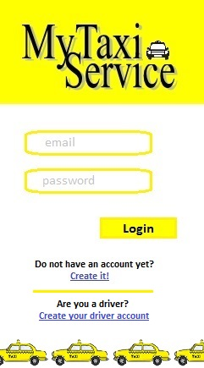

Figure 1: Homepage/Login

When the user (driver or passenger) open his/her mobile application or the website, he/she sees this page. Then if he/she already has an account he/she fills in the form and click on the button “Login” (then he/she will be send to the page showed in Image 6.3 if he/she is a passenger and to the one showed in Image 6.9 if he/she is a driver). Otherwise the user can create a new account clicking on the link “Create it!” (Image 6.2) if he/she is a passenger or “Create your driver account” (Image 6.8) if he/he is a driver.

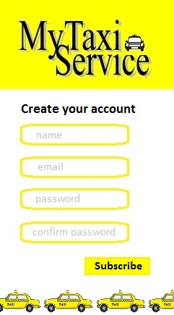

Figure 2: Passenger creation account

The passenger fills in the form with all the information requested and clicking on the button “Subscribe” the system will check if email is valid and the two password inserted are the same. Then the passenger will see a page with the new profile created (Image 6.3).

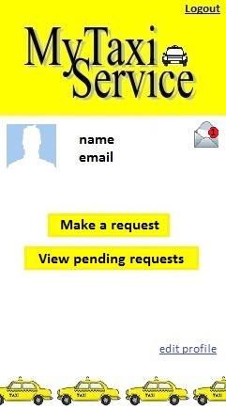

Figure 3: Passenger profile

Through his/her own profile, the passenger can see his/her name, email and notification through the envelope on the right top of the page, make a request clicking on the related button (then the passenger will see the page showed in Images 6.5), see his/her incoming requests accepted or waiting to be accepted by a driver clicking on the related button (then the passenger will see the page showed in Image 6.6), edit the profile clicking on the related link, make the logout from the system.

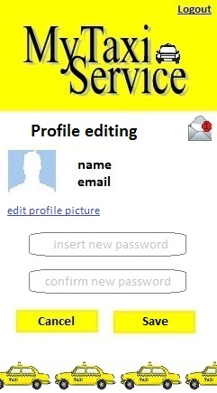

Figure 4: Passenger profile editing

The passenger can only change his/her profile picture and change the password with a new one. The clicking on the button “Cancel” the system will return the passenger on the profile page (Image 6.3) without producing any changes otherwise clicking on the button “Save” the system will save all changes and will return on the profile page (Image 6.3). From this page the passenger can see the notifications and can logout from the system.

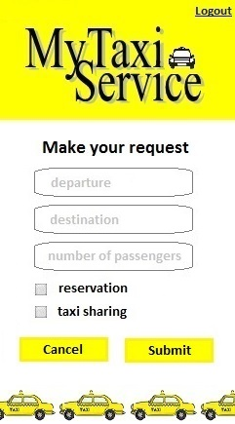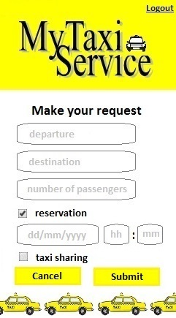

Figure 5: Passenger request form

Through this form the passenger can make a request filling departure, destination and specifying if he/she want to make a simple request or a reservation (in this case is possible to choose day and time) and if he/she want to allow taxi sharing. Clicking on the button “Cancel” the system will show again to the passenger his/her profile page (Image 6.3) and clicking on “Submit” the system will add the request to the passenger’s pending requests (Image 6.6) and show the passenger his/her profile page (Image 6.3).

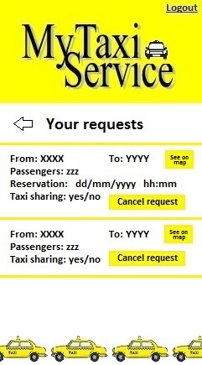

Figure 6: Passenger’s pending requests

In this page the passenger can see all the requests he/she has done and which are waiting to be evaluated or have already been accepted/ignored by the driver. Clicking on the button “Cancel request” the passenger can cancel the request and clicking on the button “See on map” he/she can see the position of the taxi driver in the map. Clicking on the arrow the system will show the passenger his/her profile page (Image 6.3).

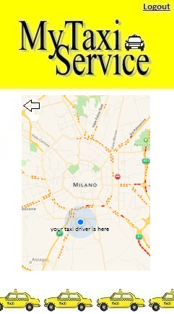

Figure 7: Passenger map

Through this page the passenger can see where is the driver assigned to the specific request. Then he/she can return to the previous page (Image 6.6) clicking on the icon with the arrow or logout clicking on the link.

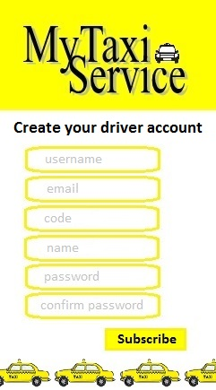

Figure 8: Driver creation account

The driver fills in the form with all the information requested and clicking on the button “Subscribe” the system will check if username, email and code correspond to data stored in Milano’s database and the two password inserted are the same. Then the driver will see his/her new profile (Image 6.9).

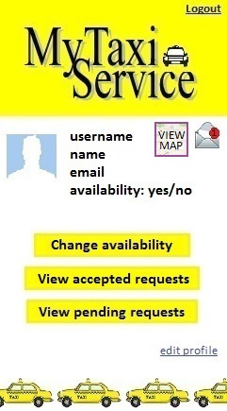

Figure 9: Driver profile

Through his/her own profile, the driver can see his/her username, name, email, availability, notification through the envelope on the right top of the page and the map with his/her position and the destinations of the accepted requests (Image 6.10), change availability clicking on the related button (then the driver will see the page showed in Image 6.11), see accepted requests clicking on the related button (then the driver will see the page showed in Image 6.12), see pending requests waiting to be accepted by him/her clicking on the related button (then the passenger will see the page showed in Image 6.13), edit the profile clicking on the related link (Image 6.14), make the logout from the system (he/she will return on the page showed in Image 6.1).

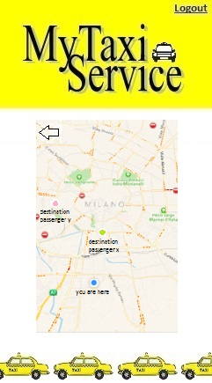

Figure 10: Driver map

Through this page the driver can see his/her position and all the destinations of the requests already accepted. Then he/she can return to the previous page (Image 6.9) clicking on the icon with the arrow or logout clicking on the link (he/she will return on the page showed in Image 6.1).

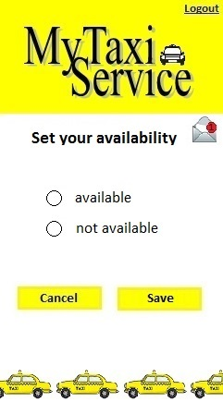

Figure 11: Driver changing availability

Through this page the driver can change his/her availability selecting the option he/she wants to choose. Clicking on the button “Save” the system will save the changes otherwise clicking on “Cancel” the system will cancel changes. In both cases the system will return the driver to the profile page (Image 6.9). From this page the driver can make logout (then he/she will see the homepage of Image 6.1).

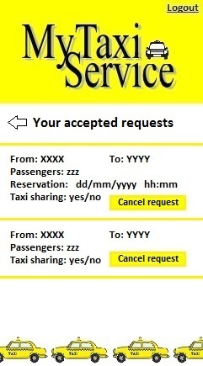

Figure 12: Driver accepted requests

In this page the driver can see all the requests he/she has already accepted. He/she can cancel each of them by clicking on the button “Cancel request”. After deleting the request the passenger will see the same page (Image 6.12). Otherwise clicking on the arrow the system will show the driver his/her profile page (Image 6.9).

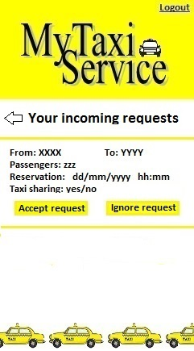

Figure 13: Driver pending requests

In this page the driver can see all his/her incoming requests. For each request the driver can choose to accept or ignore it by clicking on the related button. Clicking on one of any of the previous buttons the system will return the driver on the same page (Image 6.13). Otherwise clicking on the arrow the system will show the driver his/her profile page (Image 6.9). Driver can make logout the he will see the homepage (Image 6.1).

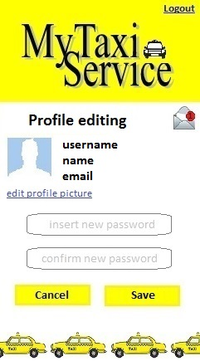

Figure 14: Driver profile editing

The driver can only change his/her profile picture and change the password with a new one. The clicking on the button “Cancel” the system will return the driver on the profile page (Image 6.9) without producing any changes otherwise clicking on the button “Save” the system will save all changes and will return on the profile page (Image 6.9). From this page the driver can see the notifications and can logout from the system.

# Requirements traceability

This final part of the document is intended to relate the presented architecture with the requirements in the RASD.

# References